1. **Install VMWare:**

Install VMWare

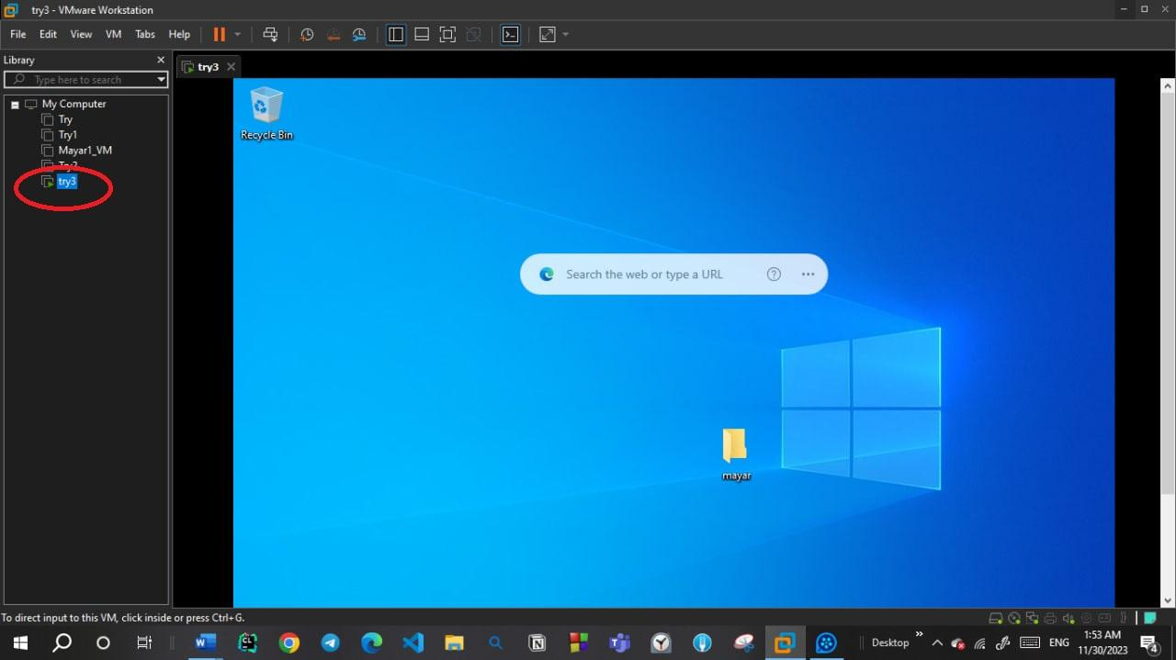

1. **Create Virtual machine.**
2. **Install Windows 10**

* Try **Rufs** program to make bootable flash memory.

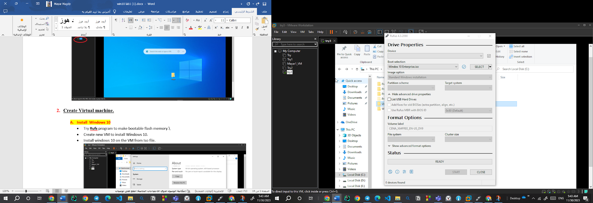

* Create new VM to install Windows 10.
* Install windows 10 on the VM from Iso file. 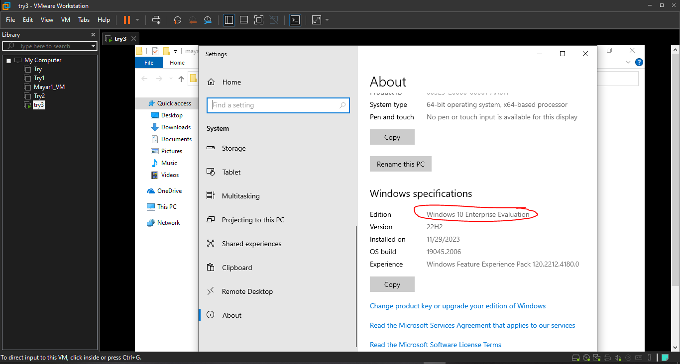

1. **from where I can Active my windows?**

R_click on computer 🡪 properties 🡪 Activate windows now🡪change product key

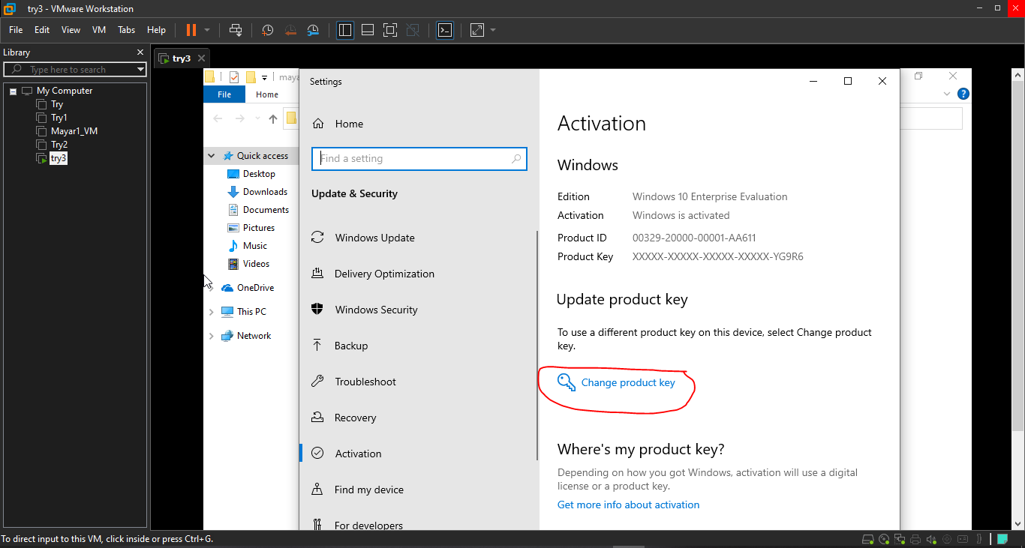

1. **Dealing with users system accounts**
   1. Using Control panel🡪user accounts and family safety 🡪user accounts🡪 manage another account

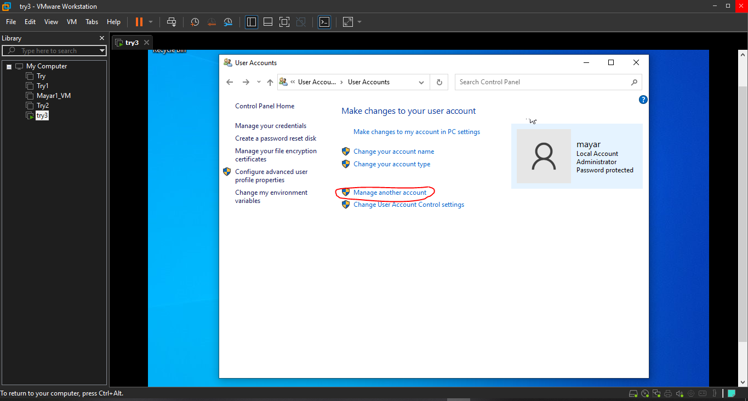

* 1. Using mmc
     1. 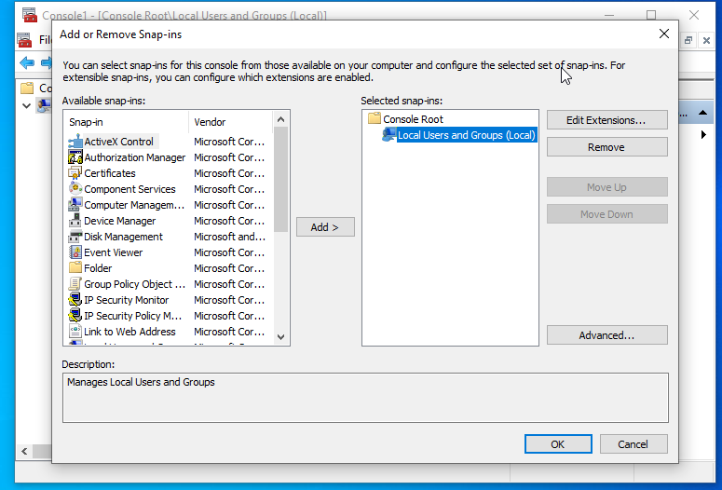Start 🡪 run 🡪 mmc 🡪 file 🡪 add remove sanp in 🡪 local users and groups 🡪 add 🡪 close
     2. Create users and groups

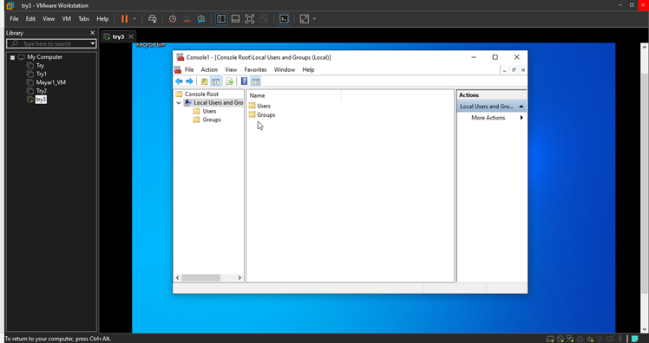

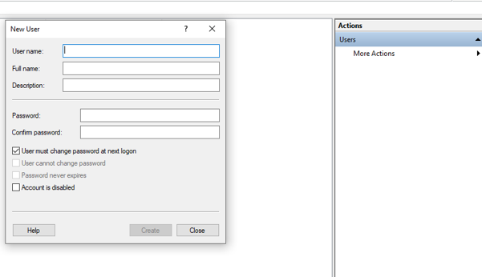 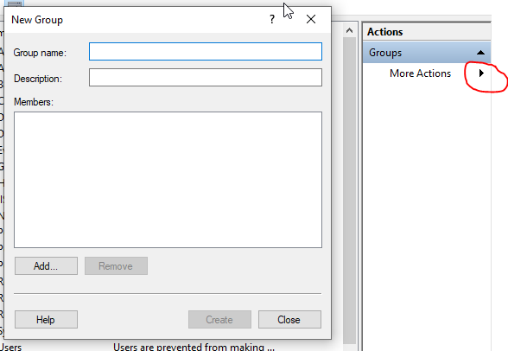

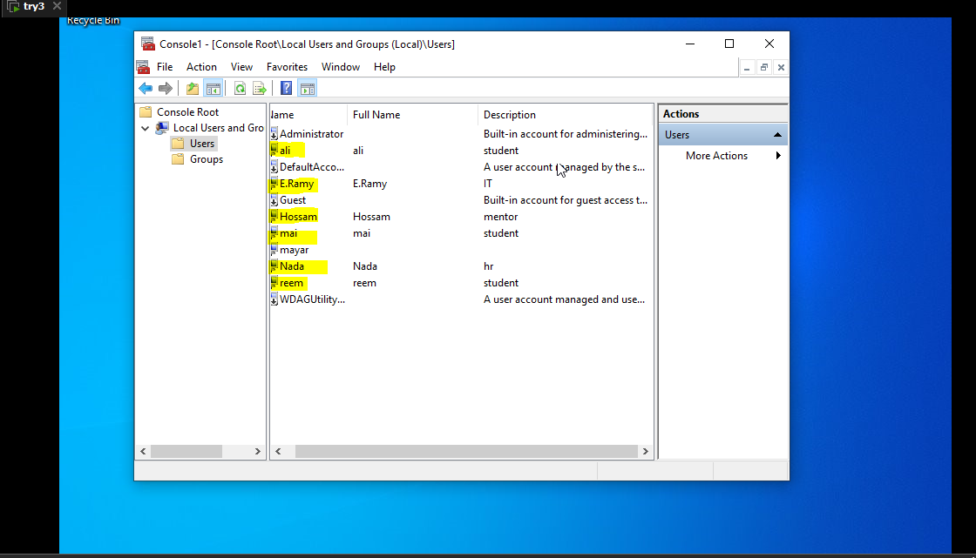

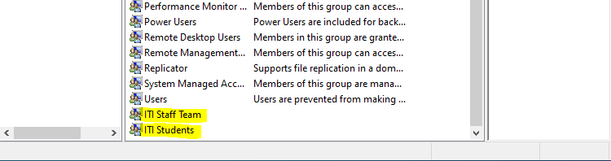

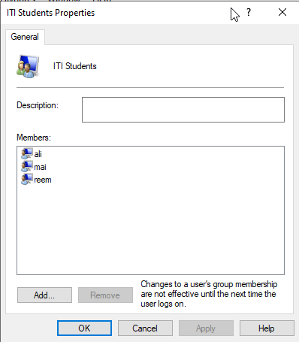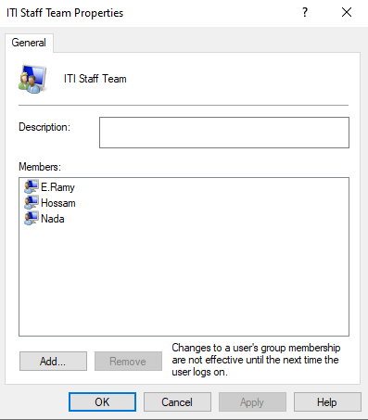

* + 1. Set Password: If you are an administrator and want to change a password without asking about the Old Password.

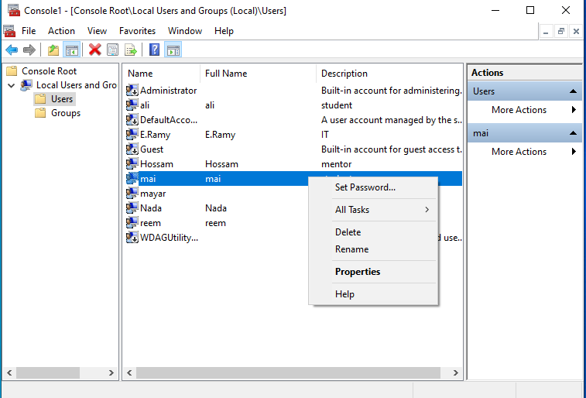

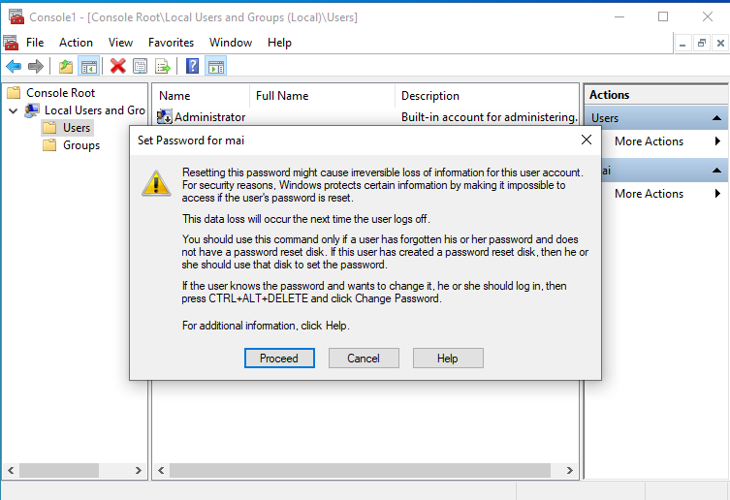

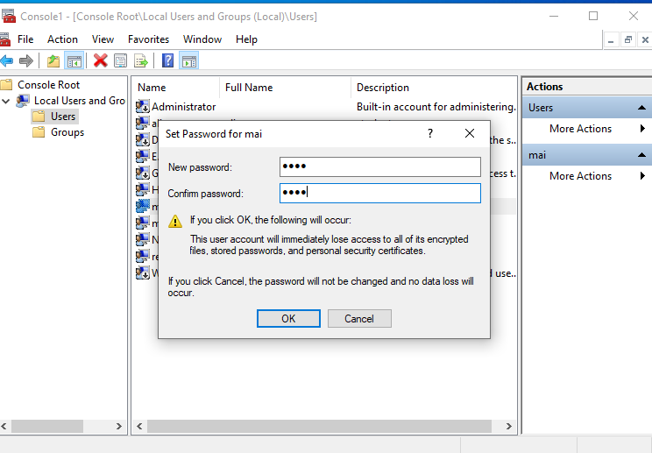

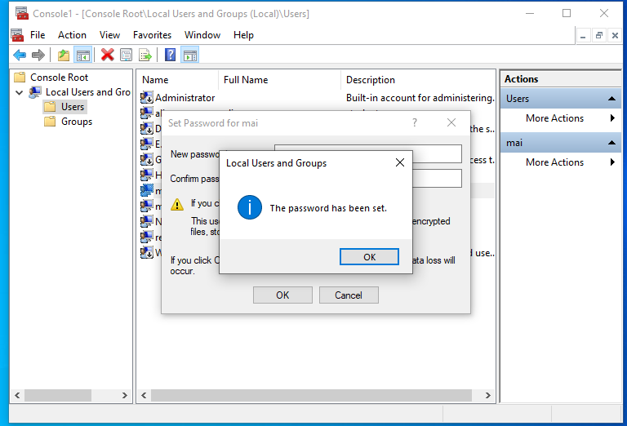

* + 1. Properties :
       1. **General** Tab

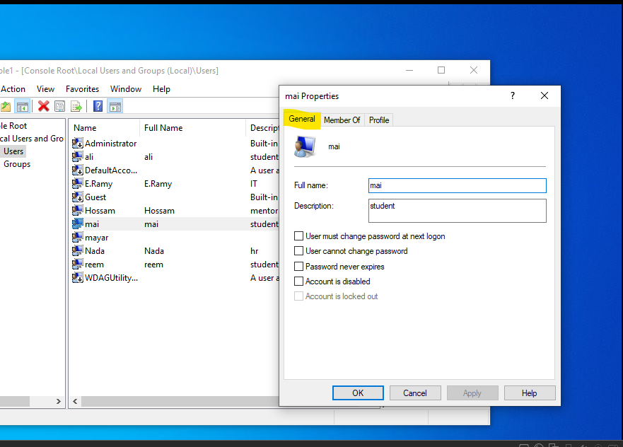

* + - 1. **Member Of** Tab: list of groups that this user is member of them, also you can Add or Remove Groups

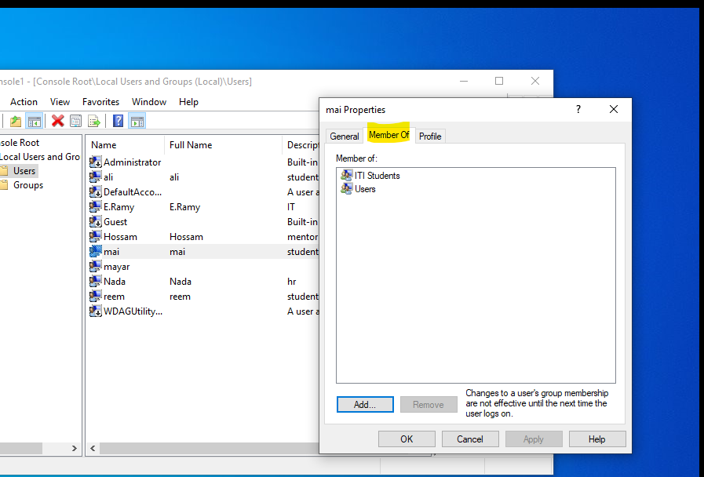

* + 1. Create New Group
       1. R-click on My computer 🡪 Mange 🡪 Local Users and Group🡪R-click🡪New group🡪add group name and members then close wizard 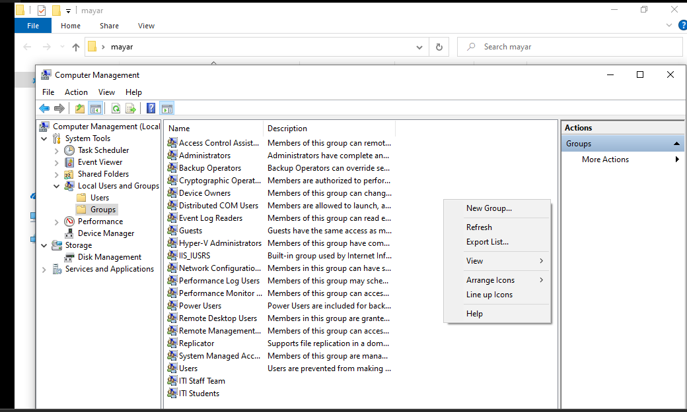



* 1. Use Default profile
     1. %Root%\users\default
     2. Default folder is hidden by default, to show hidden files and folder
        1. My Computer 🡪organize 🡪Folders and search options 🡪view Tab🡪click on view hidden files ,folders and drives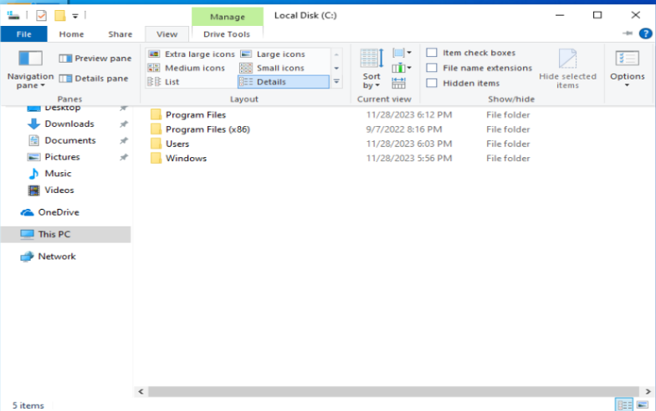

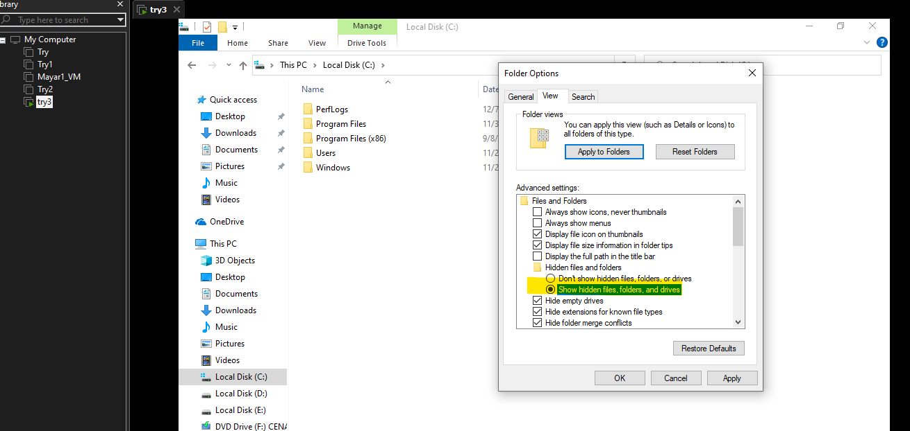

* + 1. Create a file on desktop

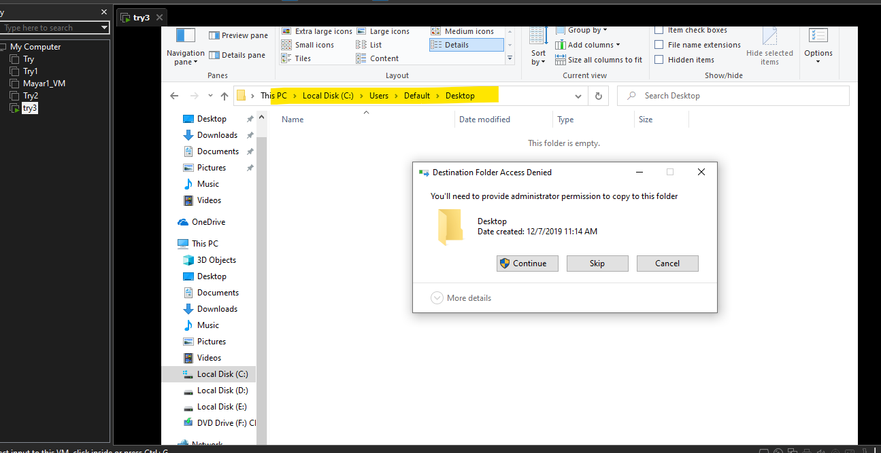

* + 1. Create a user then show the result

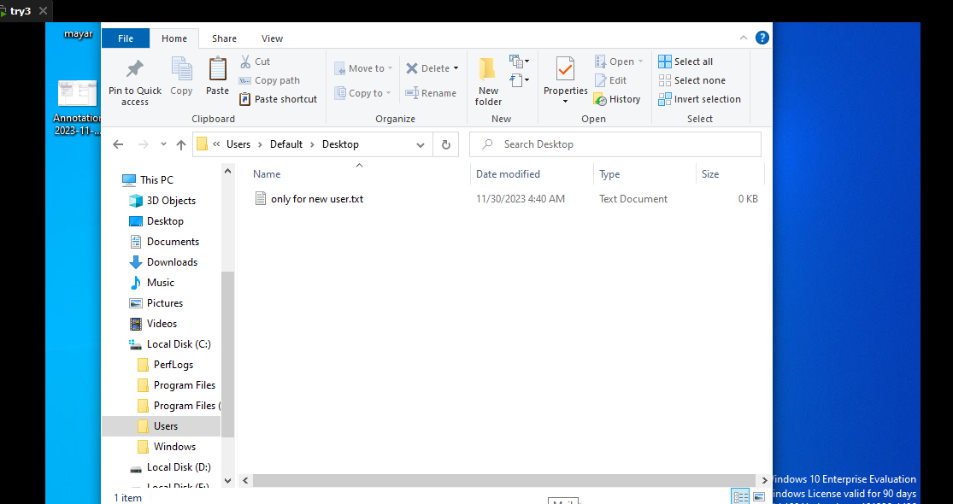

* 1. Use Public folder'

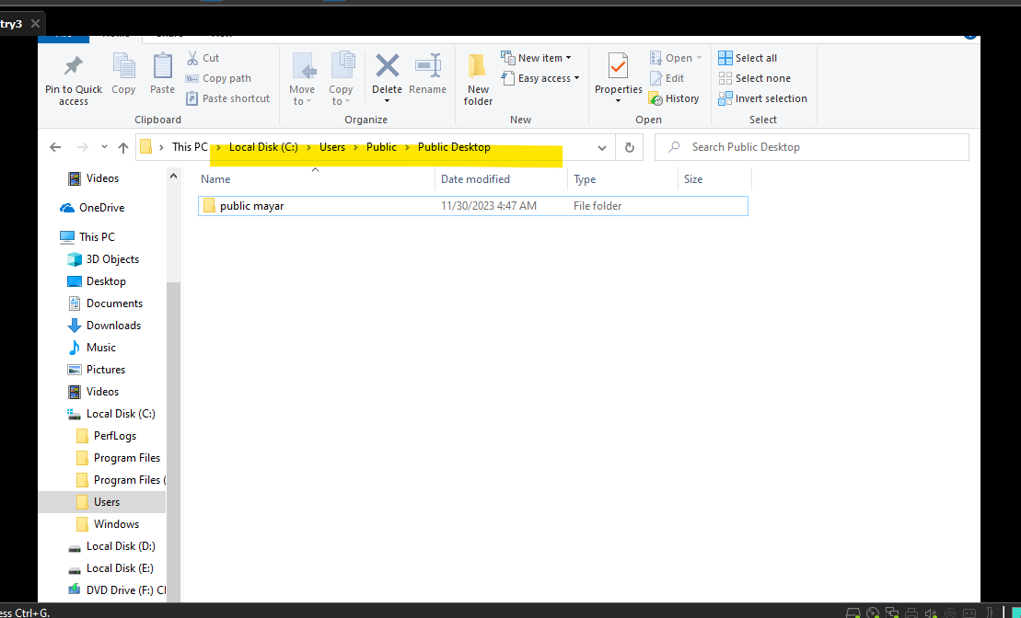

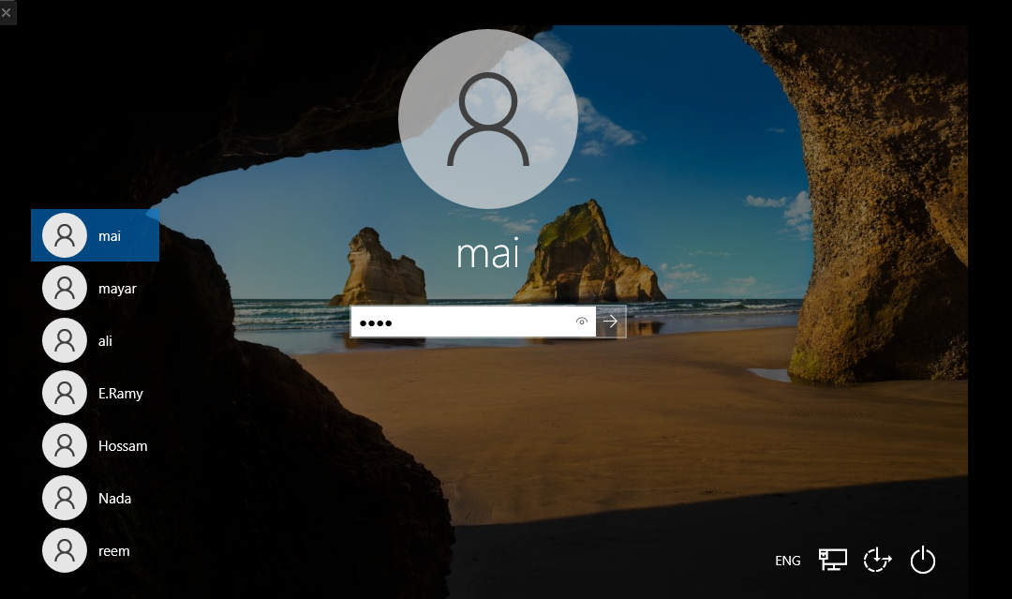

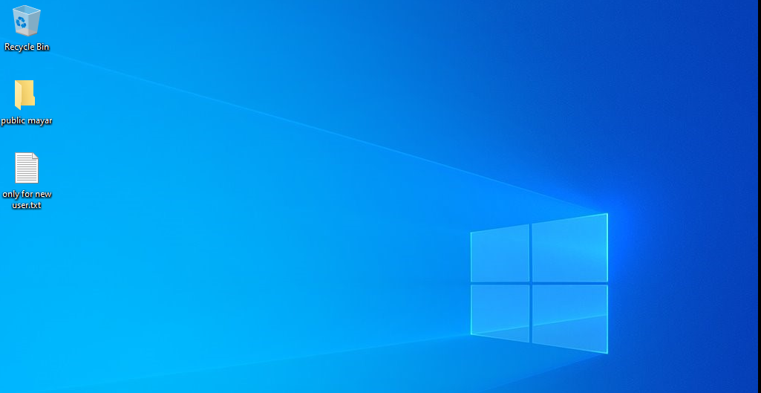

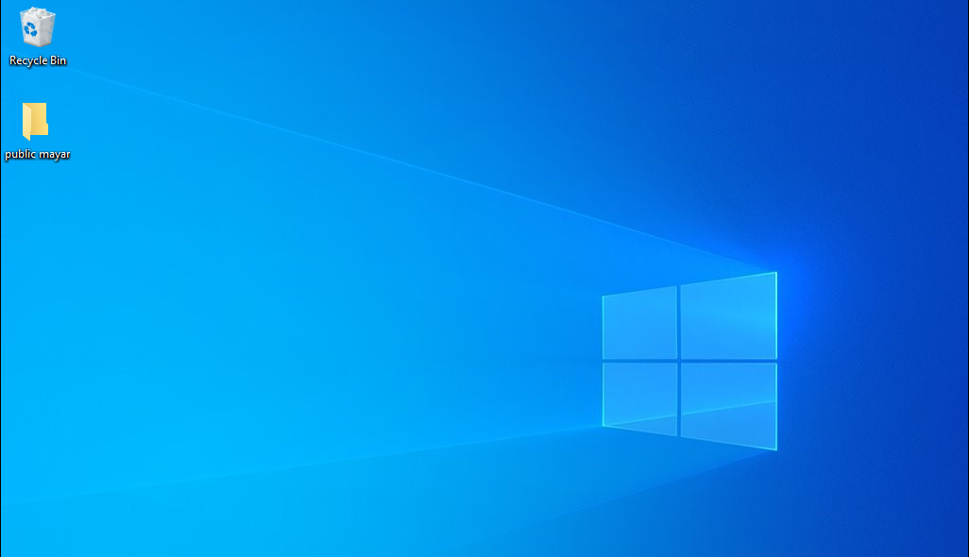

1. Configuring automatic login

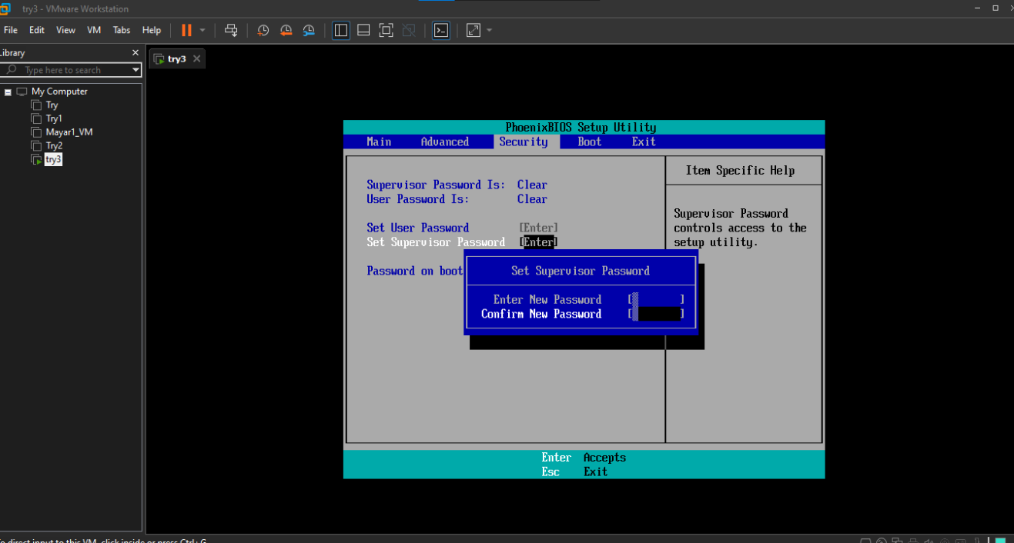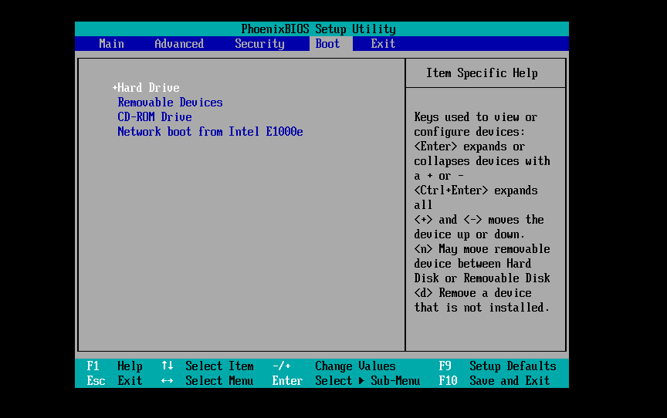

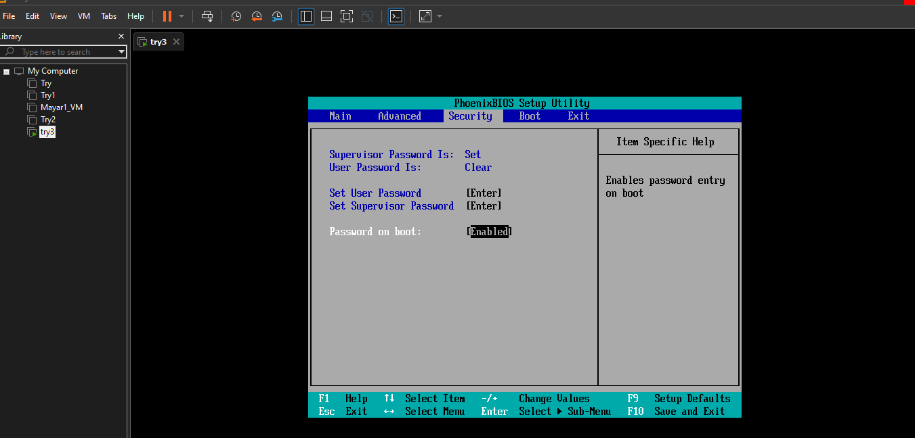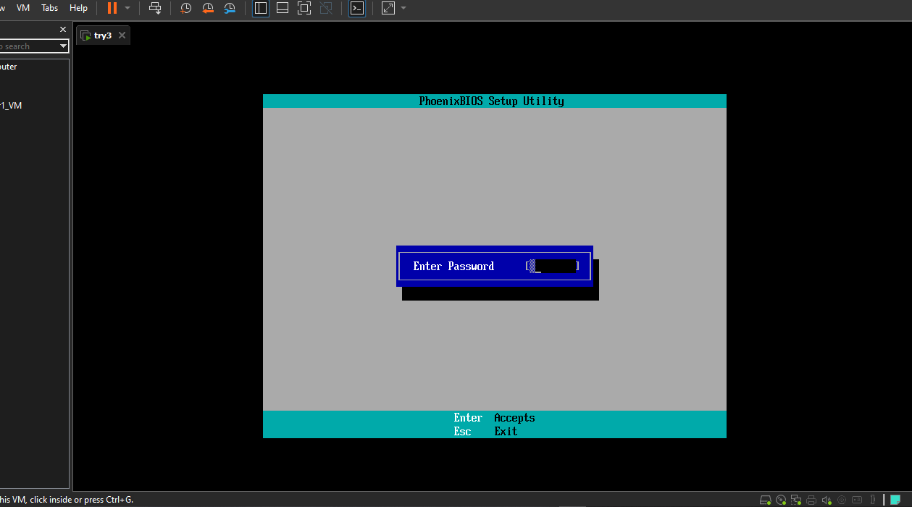

step 1: type this to run prompt:

🡪 ***control userpasswords2***

* step 2: uncheck "Users must enter a user name and password to use this computer“
* step 3: press apply button and enter user name and password.
* step 4: press ok button and reboot computer

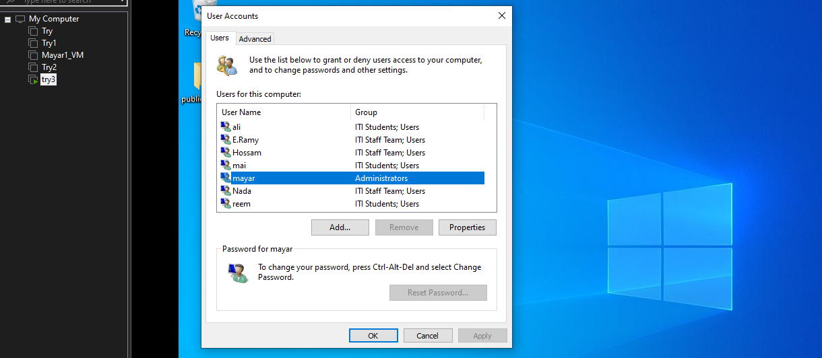

page file & Sam File

**page>> to Virtual Memory (used when memory complete 100%)**

**sam>> file contains all users passwords**

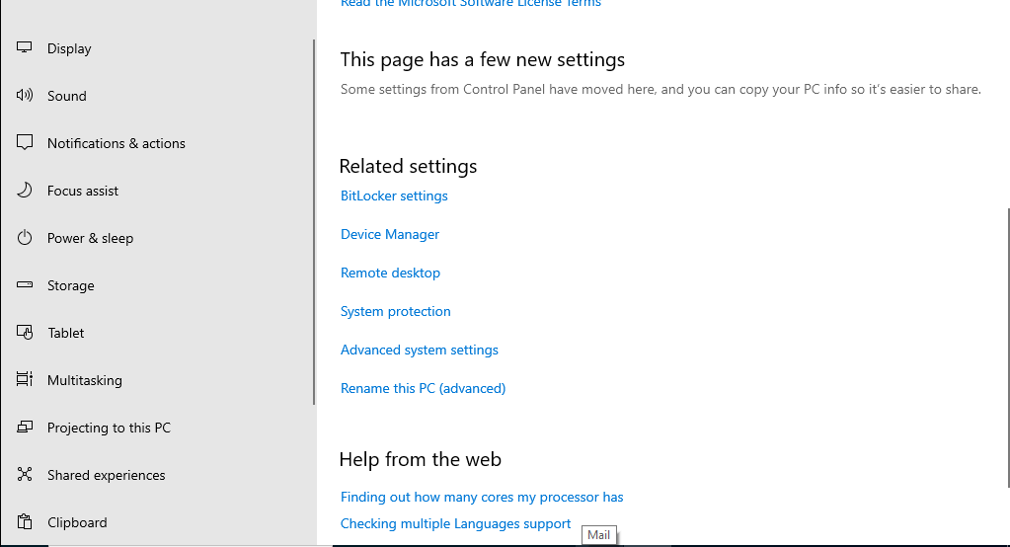

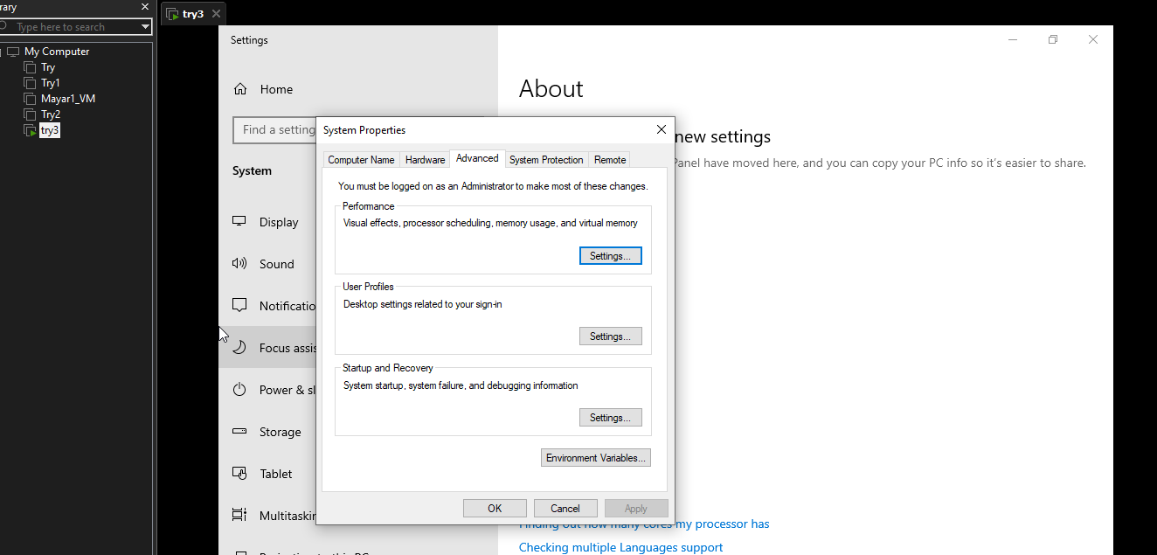

2. 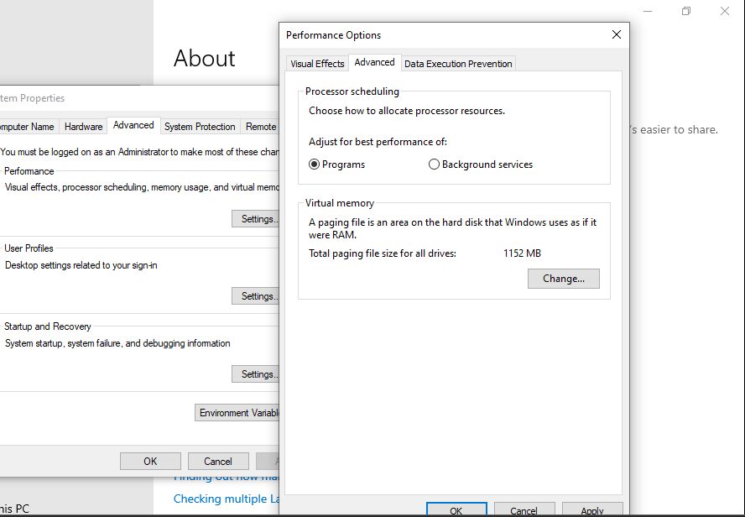

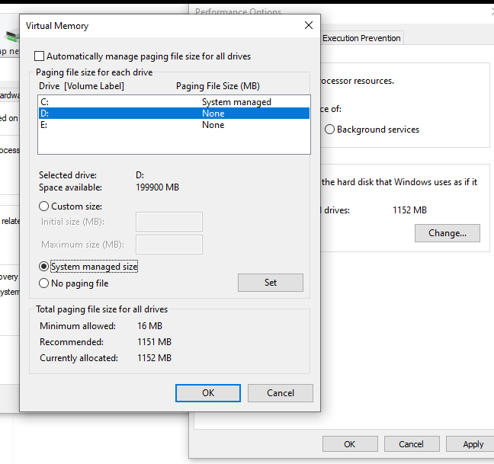

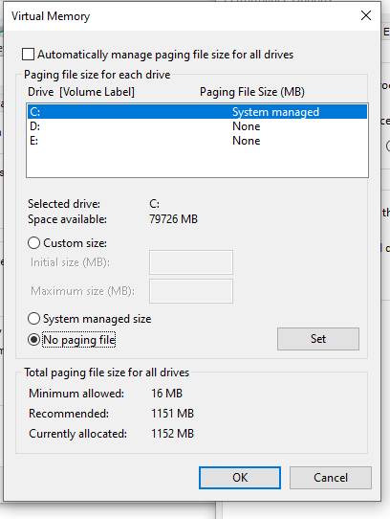

1. *“Copy to”* User Profile

* Go to System Properties - Advanced System Settings - Advanced Tab - User Profiles Settings button(RC on computer properties)
* Choose the Setup user and click "Copy To..."

1. **Check Device Manager:**
   1. R-click on  Computer 🡪 Mange 🡪 Device manager
   2. Control Panel 🡪 System and security 🡪 System 🡪 Device Manager
   3. R-Click on Computer 🡪 Properties 🡪 Device Manager

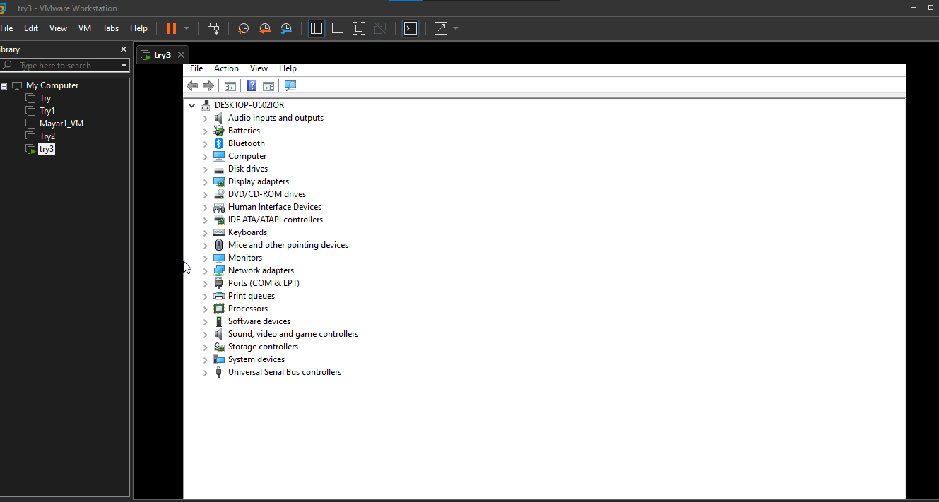

* 1. Select  and expand for example Network Adaptors 🡪R-Click on Network Card 🡪 you can Update or Disable  or Uninstall driver

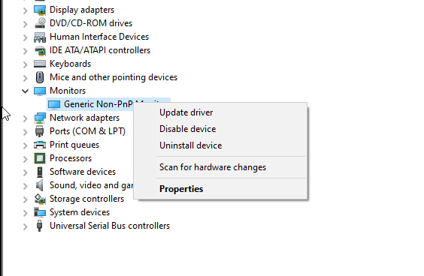

* 1. Disable Network card



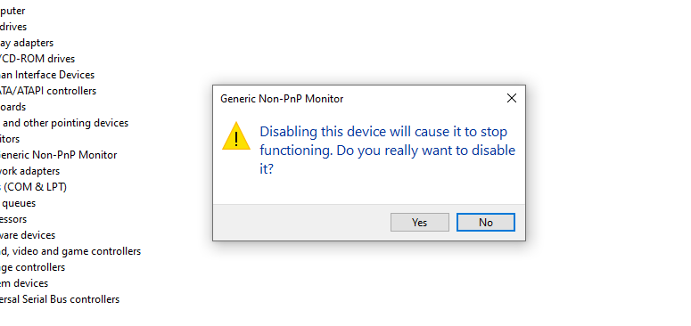

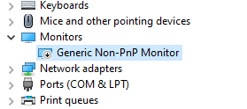

* 1. Create accounts for new users:

Asmaa, Doaa, lamiaa, shimaa, Naglaa, walaa, Aliaa, Hifaa

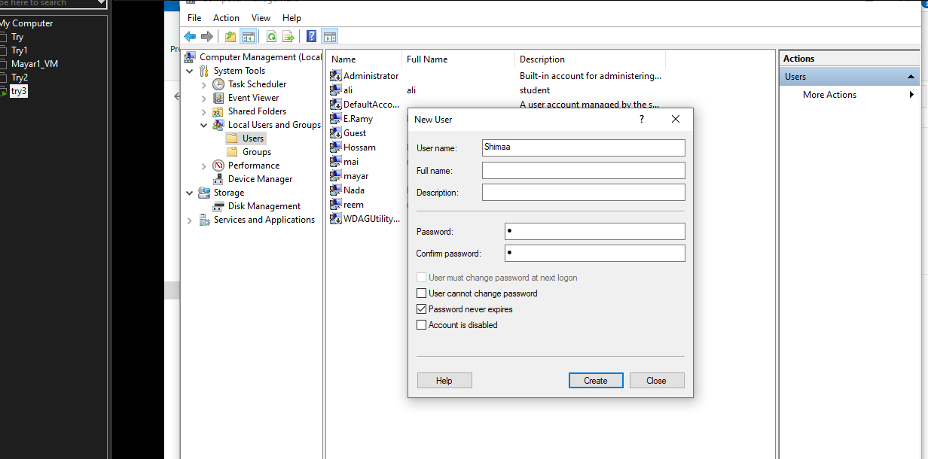

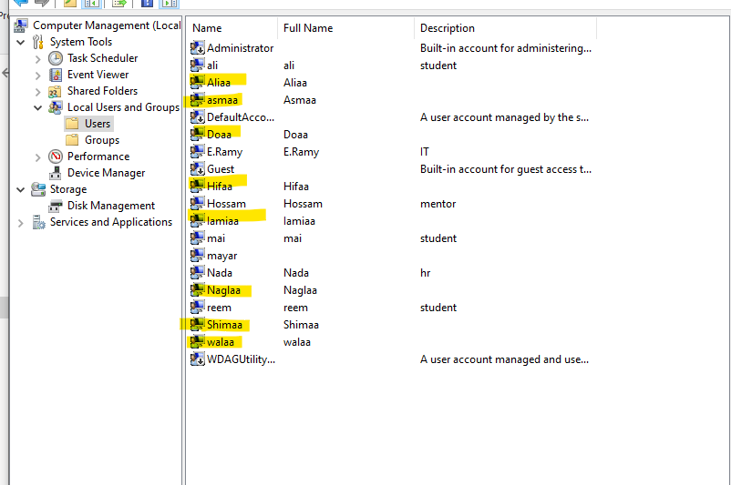

Asmaa is Admin

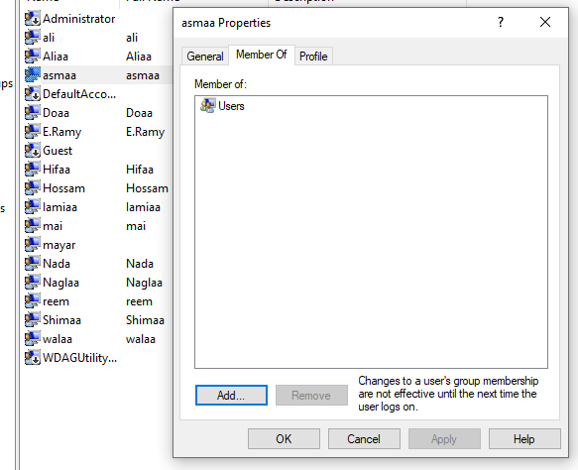

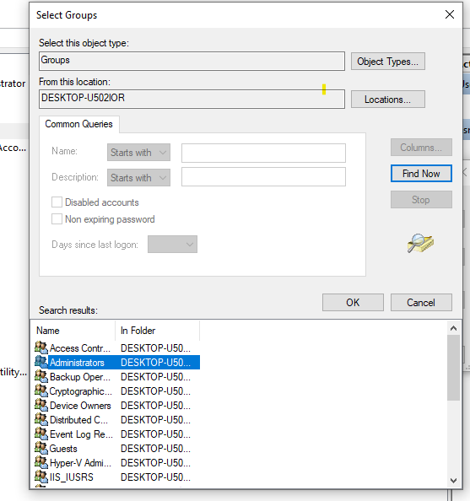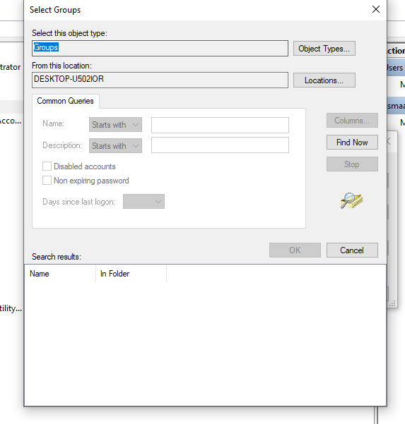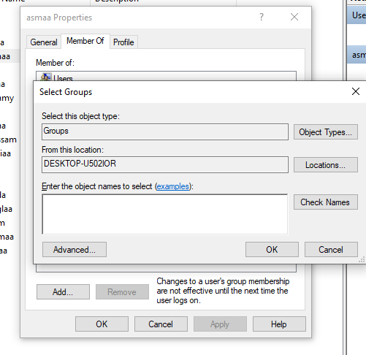

Doaa is limited user but can use Remote desktop.

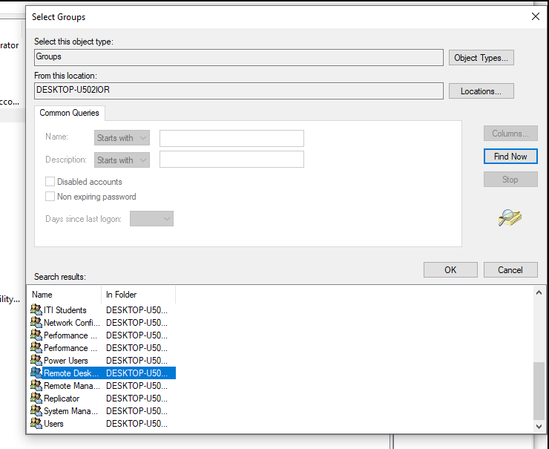

**Shimaa is Guest**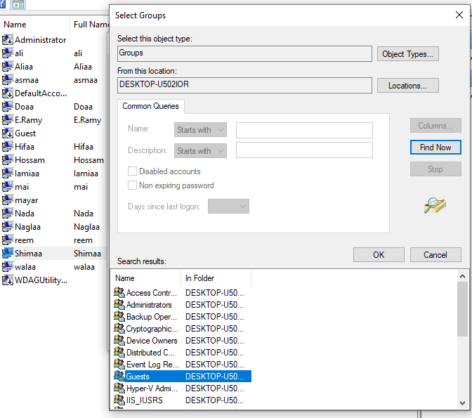

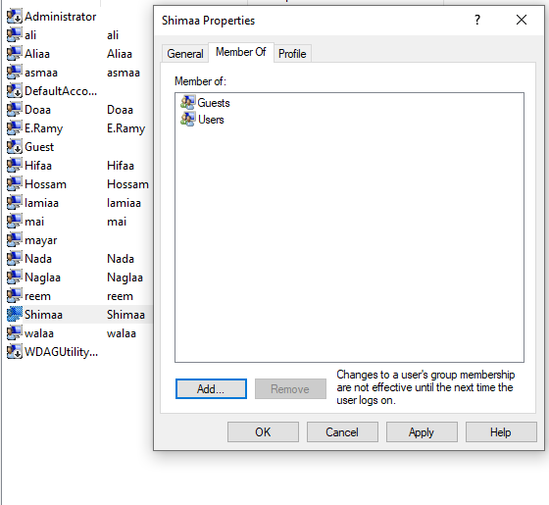

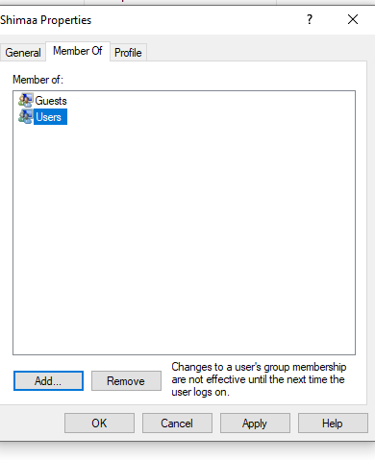

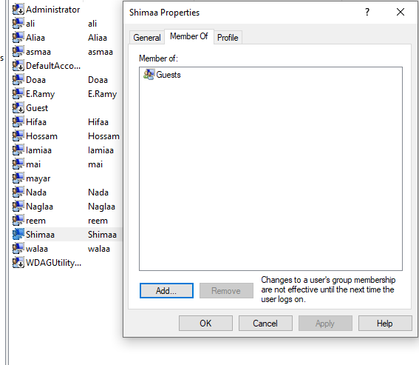

**Naglaa and walaa are members on sales group.**

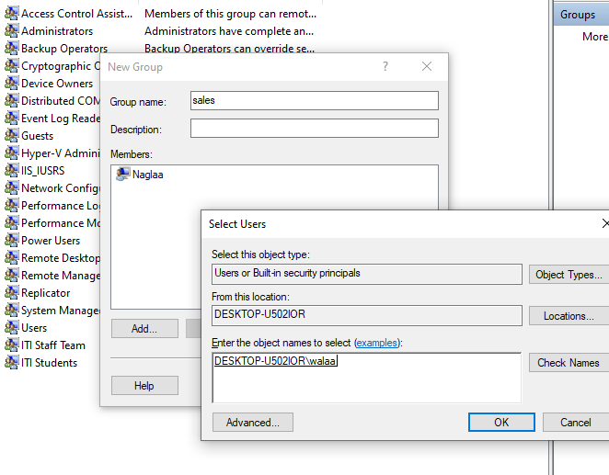

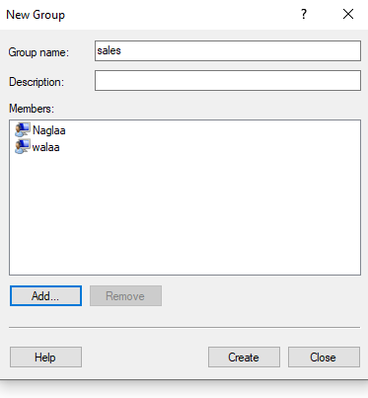

Make all limited users not able to see volume d:

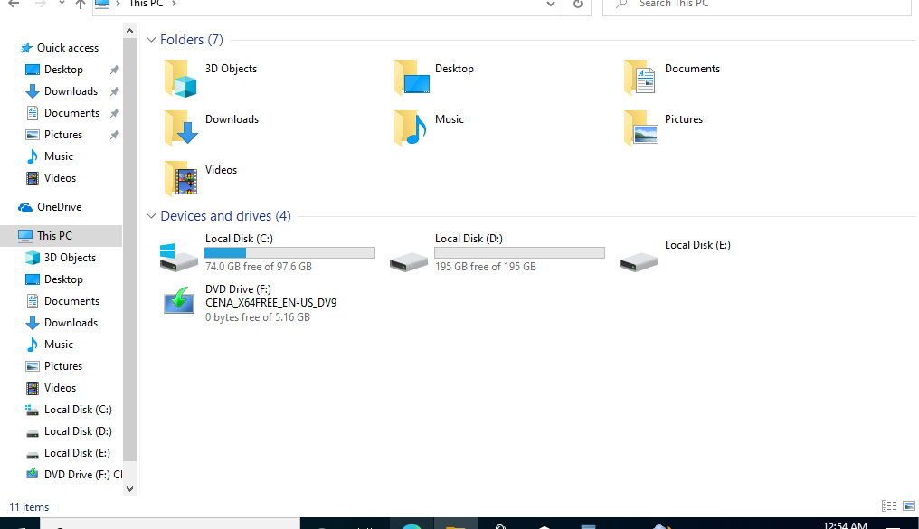

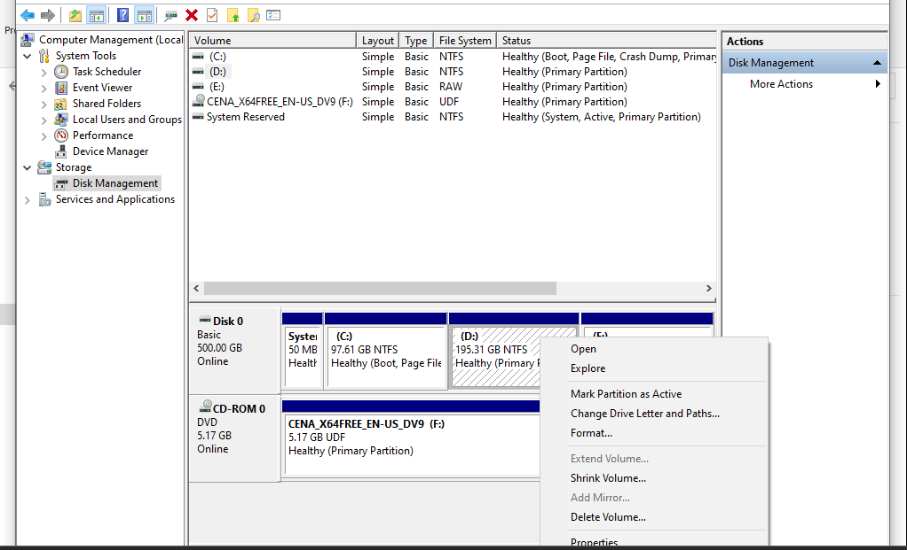

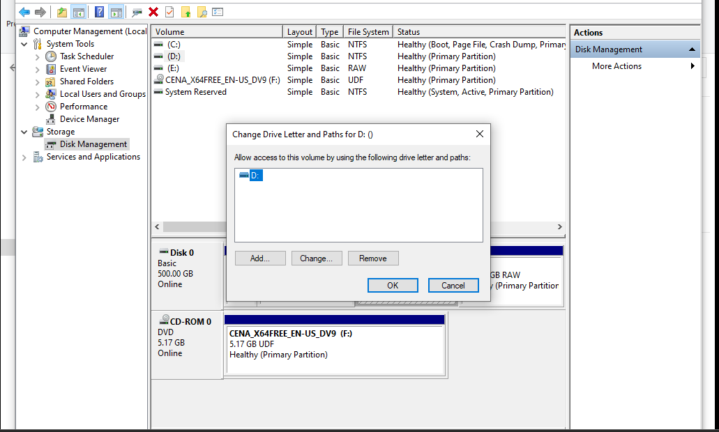

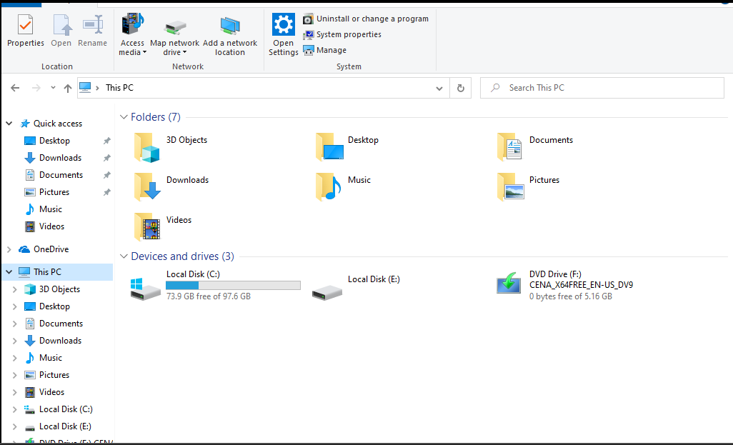

No D

1. **Managing Basic Disks:**
   1. MBR basic disk:
   * Run 🡪 mmc 🡪 Add remove snap in🡪 Add🡪 Disk management

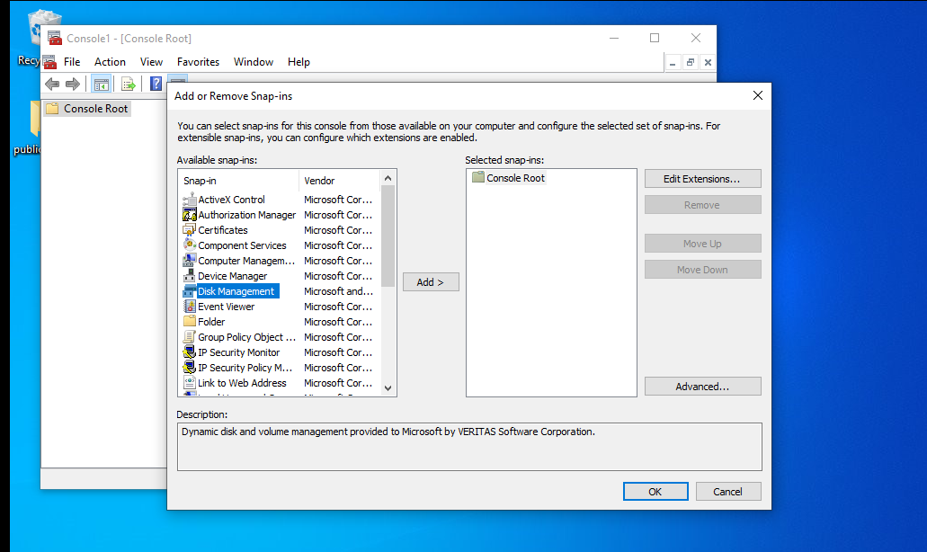

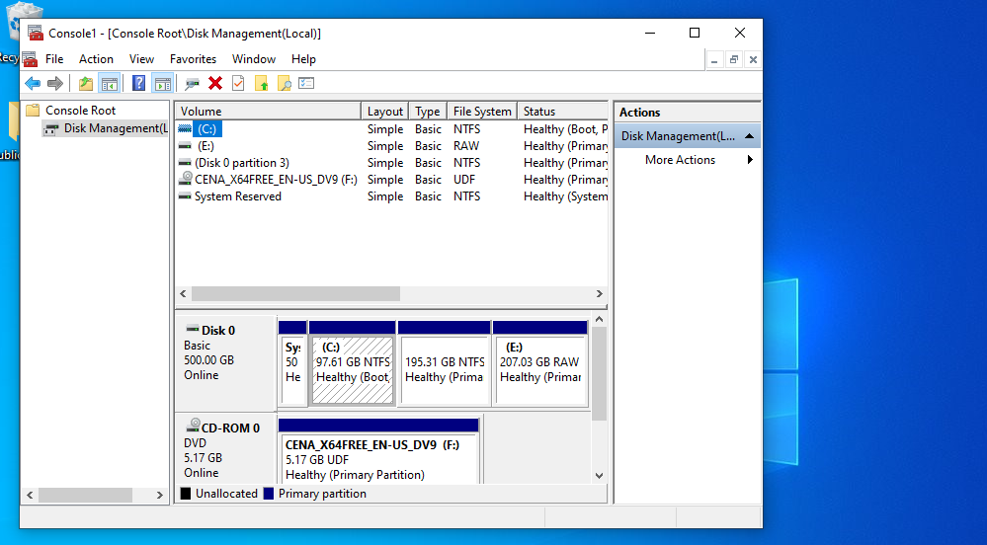

* + **Run 🡪 cmd 🡪 diskpart.exe 🡪 *list volume***

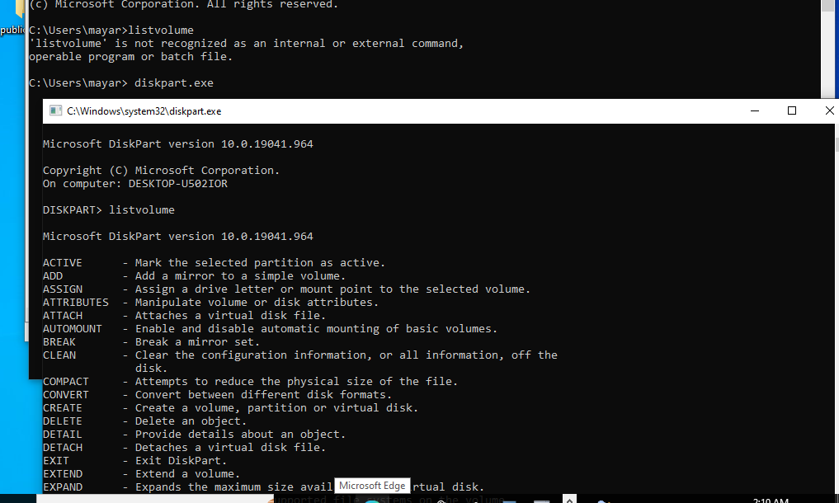

* + R-click on my computer 🡪 Manage 🡪 disk management

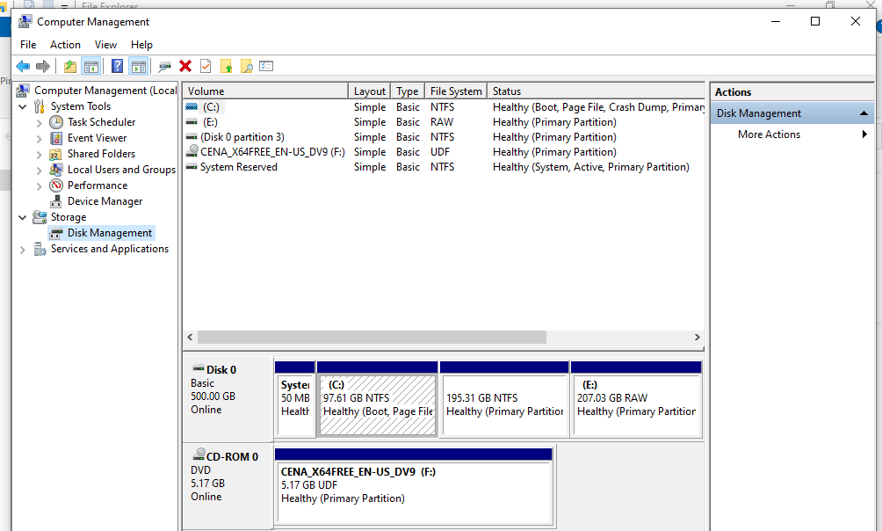

* + As your hard disk divisions

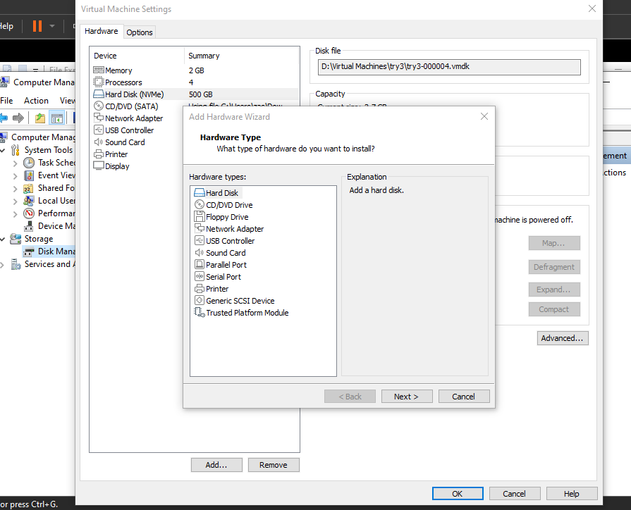

* + - Primary partition with **Dark blue** color.

* + - You may have maximum four primary partition “MBR”

* + - or maximum 3 primary partition + 1 extended partition

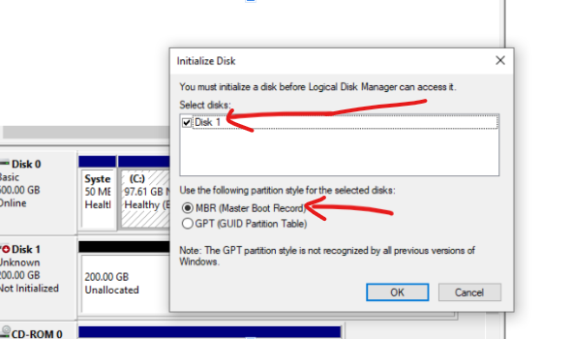

* + - Extended partition is a container to Logical partitions.

* + - Extended partition has **Dark Green** color.
    - Logical partition has **Light Green** color before formatting.
    - Logical partition has **Light Blue** color after formatting.
    - Unallocated space is unformatted space with **Black** color.

* + Convert command
    - To convert the partition's file system from FAT32 to NTFS without formatting 🡪 start 🡪 run 🡪 ***convert D: /fs:ntfs***

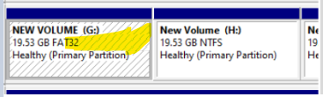

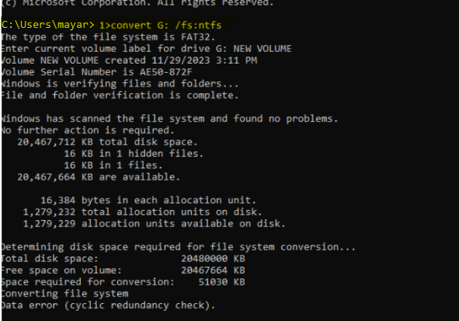

* + - Where "D" is the partition name.(G)

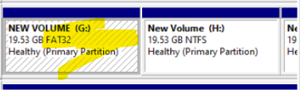

* + - This command only in one way, convert file system from fat to ntfs.
  1. GPT basic disk:
     + Add another HD (GPT) with 5 primary partition.

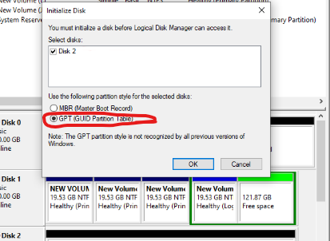

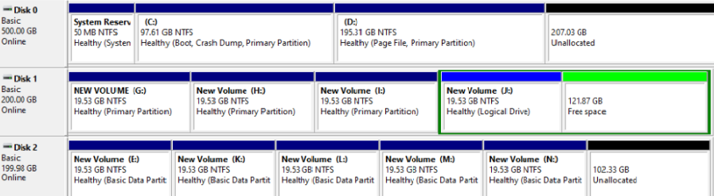

**6. Using Disk Defragmenter**

Start 🡪 type “cmd” in search 🡪 press ctrl + shift + enter 🡪 so you can run cmd with administrative privilege

>Defrag

>Defrag D: -a 🡪 analyze volume now

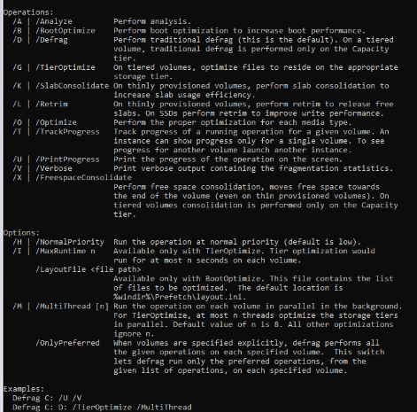

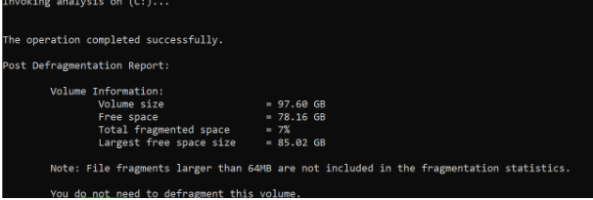

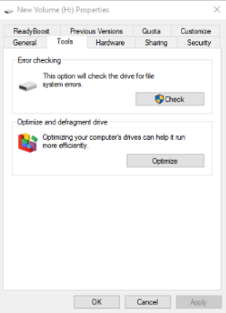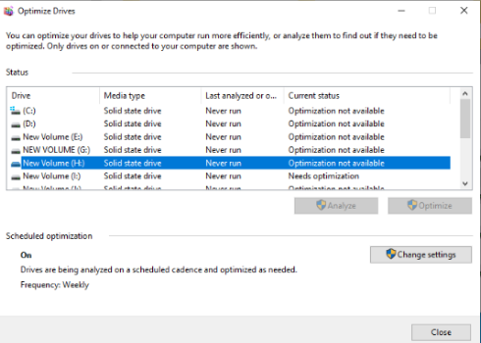**7. Dealing with mount point**

* 1. Mount point created on NTFS partition
  2. Disk Management 🡪R-click on partition 🡪 change Drive Letter And Path 🡪 Add 🡪 Browse 🡪 select your folder on NTFS partition
  3. To remove Mount point 🡪 R-click on partition 🡪 change Drive Letter And Path 🡪 select your Mount point 🡪 remove

**8. Dealing with shrink option**

Disk Management 🡪R-click on partition 🡪 Shrink volume

Disk Management 🡪R-click on partition 🡪 Extend Volume